**Lab-10 Assignment**

**1)C++ program for Hospital Management and class diagram**

**Program:**

#include<iostream>

using namespace std;

class HospitalManagement

{

public:

string Hospitalname="Apollo";

string location="Vijayawada";

int beds=100;

string Doctorname="Hruthesh";

int price=10000;

void details()

{

cout<<"****Hospital details****"<<endl;

cout<<"Hospital name : "<<Hospitalname<<endl;

cout<<"Location : "<<location<<endl;

cout<<"Number of beds : "<<beds<<endl;

cout<<"Doctor name : "<<Doctorname<<endl;

cout<<"Price per bed : "<<price<<endl;

}

};

class patient : public HospitalManagement

{

public :

string patientname="Ramesh";

int patientid=69;

void patientdetails()

{

cout<<"****Patient details****"<<endl;

cout<<"Patient ID : "<<patientid<<endl;

cout<<"Patient name : "<<patientname<<endl;

}

void details()

{

cout<<"Patient Doctor name : "<<Doctorname<<endl;

cout<<"Price per one day : "<<price<<endl;

cout<<"Submitted by G.Hruthesh Reddy,Admn.No.20BCB7031"<<endl;

}

};

int main()

{

HospitalManagement hm;

patient p;

hm.details();

p.patientdetails();

p.details();

}

**Output:**

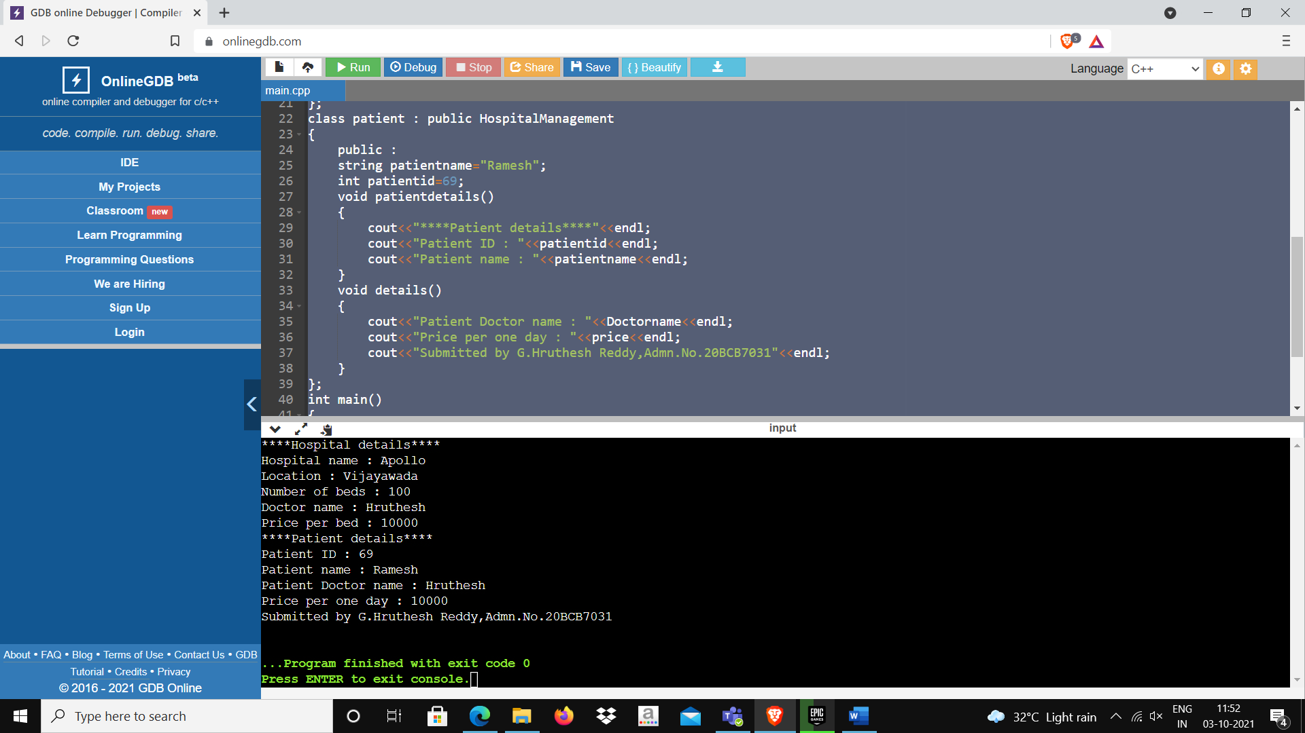

**Class Diagram:**

**2)C++ program for Bank Applications and class diagram**

**Program:**

#include<iostream>

using namespace std;

class Bank

{

public:

string Bankname="HDFC";

string location="Vijayawada";

void details()

{

cout<<"****Bank details****"<<endl;

cout<<"Bank name : "<<Bankname<<endl;

cout<<"Location : "<<location<<endl;

}

};

class Account : public Bank

{

public :

string accountname="Ramesh";

int accountno=1234;

int balance=10000;

int withdraw;

void accountdetails()

{

cout<<"****Account details****"<<endl;

cout<<"Account Number : "<<accountno<<endl;

cout<<"Account holder name : "<<accountname<<endl;

cout<<"Balance Amount : "<<balance<<endl;

}

void withdrawl()

{

cout<<"Enter amount to withdraw : ";

cin>>withdraw;

if(withdraw>10000)

cout<<"Insufficient Balance"<<endl;

else{

int remainingbalance=balance-withdraw;

cout<<"Balance amount after withdrawl : "<<remainingbalance<<endl;

}

cout<<"Submitted by G.Hruthesh Reddy,Admn.No.20BCB7031"<<endl;

}

};

int main()

{

Bank b;

Account a;

b.details();

a.accountdetails();

a.withdrawl();

}

**Output:**

**Class Diagram:**

**3)C++ program for product manufacturing and class diagram**

**Program:**

#include<iostream>

using namespace std;

class Product

{

public:

int id=6749;

string productname="Good_day";

int qty=10;

int price=10;

int ta=price*qty;

void details()

{

cout<<"****Product details****"<<endl;

cout<<"ID of the product : "<<id<<endl;

cout<<"Product name : "<<productname<<endl;

cout<<"Quantity : "<<qty<<endl;

cout<<"Price : "<<price<<endl;

cout<<"Total Price : "<<ta<<endl;

}

};

class Seller : public Product

{

public :

string sellername="Ramesh";

string l="Vijayawada";

int sellerid=1234;

void sellerdetails()

{

cout<<"****Seller details****"<<endl;

cout<<"Seller ID : "<<sellerid<<endl;

cout<<"Seller name : "<<sellername<<endl;

cout<<"Location : "<<l<<endl;

cout<<"Submitted by G.Hruthesh Reddy,Admn.No.20BCB7031"<<endl;

}

};

int main()

{

Product p;

Seller s;

p.details();

s.sellerdetails();

}

**Output:**

**Class Diagram:**

**Time of Submission:** 4/10/21, 16:25